**UNIT 9: Praising and Raising Complaints**

**At the end of the lesson, students will be able to:**

Understand work quality

Accepting complaint

Responding to praising

Praising colleagues

Problem-solving skill



**STARTER**

**Activity 01: Pair work**

1. Have you ever praised someone? If yes, who and why?
2. Do you think praising someone is good?
3. Do you think praise is important at the workplace? Why or why not?
4. Do you like to praise other people, or do you like to be praised?
5. Have you ever known someone who everyone praised and admired? Who?

**Activity 02**: **Reading Task**

Pre-reading: Matching

Match the adjectives with the definition.

|  |  |  |
| --- | --- | --- |
| **Adjective** | **Definition** | **Answer** |
| 1. Happy | A. Having or displaying a strong desire to be more successful than others | 1. ______  2. ______  3. ______  4. ______  5. ______  6. ______  7. ______  8. _______  9. _______  10. ______ |
| 1. Serious | B.Behaving in a pleasant way to other people. |
| 1. Friendly | C. Having a lot of belief in yourselves. |
| 1. Confident | D. Being generous to other people and thinking about other people's feelings |
| 1. Kind | E. hopeful and confident about the future |
| 1. Shy | F. Relating to or belonging to a profession |
| 1. Hard-working | G.Being nervous or uncomfortable with other people. |
| 1. Competitive | H.Having a positive feeling of pleasure and satisfaction. |
| 1. Professional | I.Doing a lot of work all the time and keeping busy |
| 1. Optimistic | J. Thinking a lot and not joking or laughing very much |

## Someone I Really Admire/Praise

#### My cousin Laura

Someone I admire is my cousin Laura. She’s five years older than me, so she’s 19 now and she lives in Bristol. She’s very friendly and confident and she’s got long, wavy, brown hair and greeny-brown eyes. She’s medium height, slim and very fit because she’s a dancer.

She’s been dancing since she was six years old and trains every day at her dance school. She wants to be a professional dancer, but it’s a very difficult profession because it’s so competitive. She often dances in shows and I’ve been to watch her several times. Her favorite type of dance is modern, which is sometimes a bit strange, but I love watching her dance.

Laura is very busy because she also studies photography at university. She’s a really good photographer and has taken lots of amazing photos of me and my family. Her photos have won a few prizes and last year one of her photos was in an exhibition at an art gallery in London.

Laura doesn’t have a lot of free time and she’s also trying to learn German because she wants to go to Germany next year to do a photography course. I think Laura is very hard-working and she deserves to become a professional dancer one day.

**Activity 03: MCQ Questions**

Read the short reading again and choose the correct answer of the following:

1. Laura currently lives in ____________.
2. London B. Bristol
3. C. Germany D. Brighton

2. Laura started dancing when she was __________.

A. 5 B. 6

C. 19 D. 16

3. Laura goes to university and studies ________.

A. Germany B. Dance

C. Photography D. Physics

4. Laura has won prizes for her __________.

A. Photography B. Dancing

C. Language Skill D.Beauty.

5. Laura's dream is to be a _____.

A. German teacher B.Professional dancer

C. Professional photographer D. An artist

6. Laura is very _____.

A. Busy and hard-working B. Beautiful and kind

C. Fit and strong D. Nasty and lazy

7. Laura always practices dancing at her ________.

A. school B. house

C. university D. dance school

8. What is Laura’s personality?

A. friendly and confident B. long wavy-brown hair

C. greeny brown eyes D. slim and fit

9. Why is Laura trying to learn German?

A. Because she doesn’t have enough free time.

B. Because she studies photography.

C. Because she is hard-working.

D. Because she wants to go to Germany and take a photography course there.

10. Laura’s favorite type of dance is __________.

A. hip-hop B. strange

C. jazz D. modern

**Activity 04: Place the words in the correct group.**

|  |
| --- |
| slim competitive friendly brave tall overweight confident fat  hard-working blonde selfish handsome positive moody chubby  medium-high reliable bald polite skinny patient tattooed shy |

|  |  |
| --- | --- |
| **Appearance** | **Personality** |
| **Slim**  **Tall**  **Overweight**  **Fat**  **Blonde**  **Handsome**  **Chubby**  **Medium-high**  **Bald**  **Skinny**  **Tattooed** |  |
|
|
|
|
|
|

**Activity 05: Gap filling**

Choose the words from the box to fill in the gap of the following reading.

|  |
| --- |
| dream blond London sad creative young fit hard-working patient better successful brother |

**My Brother**

Someone I admire is my (1)brother David. He is seven years older than me, so he is 23 now. He has recently moved to (2)London for his new job. He is very friendly, (3)patient and he has a good sense of humor. He is tall and has short (4)blond hair. David has loved computer games since he was a child. Now he designs new computer games, so he is very (5) creative. He can also speak Chinese very well and his (6)dream is to work in China in the future. David is also very (7) fit because he loves to play sports, especially football. When I visit him in London he often takes me to watch live football! It's great. When we were (8)young, we used to play football in the garden, but he was much (9)better than me. David doesn't have a lot of free time these days because he works so hard. I really admire how (10)hard-working he is and how (11)successful he has been in his career. I always look forward to visiting him but I will be (12) sad if he moves to China.

**Activity 06:**

Listen to the recording about Richard Branson, a British billionaire, entrepreneur and a very successful man. Do you know him? Listen carefully to his short biography and fill in the gaps below.

Richard Branson is the owner and founder of the Virgin Group, with different brands all around the world. Music labels, (1)_air line_______, wines, you name it. You are probably thinking that my parents were rich, and that’s why he’s so (2)succesfull____________. But you’re wrong. You see, he had dyslexia when he was (3)_young_______, and because of it, his grades in school were very low. His (4)_headmaster__________, Robert Drayson, said that either he was going to end in jail, or he would become a (5)__________. And he was right! 

Richard first wanted to grow and sell Christmas trees, and he also tried to resell CDs. But when both of those (6)_project________ failed, he decided to found his own (7)_________, Student. He started earning money, started to publish other (8)_________, as well as some of my own, and the rest is (9)_history__________. Richard Branson says there is no point in starting your own business unless you do it out of a sense of (10)_frustration_________.

W

**Activity 07: Discussion**

1. Do you know Sir Richard Branson?
2. What are his achievements?
3. Find one famous quote from him and discuss it in a team.
4. Tell the class about his biography.



**Activity 08: Writing**

Write a description of someone you admire. Think about:

* his/her appearance
* his/her personality
* his/her talents that you admire
* his/her achievements.

**Someone I admire(My parents)**

Who that I always admire and appreciate are my parents, they really hard-working to feed me since I was born until now, I really appreciate them how they tries to fight with a lot of enemies that came to my family. My parents who are the best people in my hard, they are my heroes in my real life. They are poor, but they never make the bad day to someone, they never break the social rule. Since I gotten 6 years old, they always support me to study until now, they never disagree with my learning. Sometime they didn’t have much money to buy the food for eating, but they kept their money to give me come school, they really love me. To sum up, they are the best parents in my hard that I really admire all their kind, hard-working, and they are the best heroes that stay to supporting me in my real life.

**Reading I: What is work quality?**

Work quality is a term that can be used to measure how effective, efficient, and accurate work is. It can be measured in terms of the quantity and quality of output produced, or in terms of the time taken to produce an output. Knowing the different types of work quality can help you to set standards for your team and ensure that everyone is working to the same high standard.

Quality work is when a person does their job in a way that is effective, efficient, and accurate. This means that they produce a lot of good work in a short amount of time, and it is all correct. The elements that make up quality work are:

* **Accuracy**: This means that the work is free from mistakes and it meets all the requirements.
* **Efficiency**: This means that the work is done promptly and it uses the resources available in the best way possible.
* **Effectiveness**: This means that the work achieves its goal and it produces the desired results.

**Why is quality working important?**

Quality work is important because it can have a positive impact on many different areas of your life. For instance, if you are a student and you hand in a high-quality essay, you are more likely to get a good grade. In the workplace, quality work can lead to promotions and pay rises. It can also help you to build a good reputation so that you are more likely to get new clients or customers. Generally speaking, quality work is just better all-around. It saves time, money, and stress in the long run so it is always worth striving for. There are various benefits of quality work, amongst which are the following: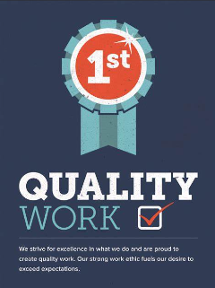

* Increased productivity
* Improved accuracy
* Faster turnaround times
* Reduced stress levels
* More time for leisure activities
* Enhanced creativity and innovation
* Greater job satisfaction
* Better working relationships with colleagues
* More opportunities for career advancement
* Improved profitability

**How to improve work quality**

**Complete difficult tasks first.**

By getting the most difficult tasks out of the way first, you can focus on the easier tasks later in the day. This will help improve your work quality overall. In addition, this ensures that you are less tired at the beginning of the day when you are more likely to make mistakes.

**Prioritize focus**

It is important to focus on one task at a time to get it done well. This can be difficult, especially if you have a lot of tasks to complete in a day. One way to help with this is to create a list of all the tasks that need to be completed and then tackle them one by one. Another way to improve focus is to eliminate distractions. This may mean turning off your email notifications or putting your phone away while you work.

**Know your strengths and weaknesses** 

Knowing your strengths and weaknesses can help you delegate tasks accordingly and set yourself up for success. Knowing your strengths and weaknesses can help you delegate tasks accordingly and set yourself up for success. On the other hand, if you find that you make more mistakes when you are tired, you may want to schedule breaks throughout the day or start working on difficult tasks earlier.

**Keep a communication a priority** 

Communication is key in any workplace. To maintain quality control, it is important to keep lines of communication open. This means being clear about expectations, deadlines, and goals. It also means being available to answer questions or offer help when needed. If there are problems with work quality, they need to be addressed as soon as possible. By keeping communication a priority, you can help prevent small issues from turning into big problems.

**Activity 09: Group Discussion**

1. What is work quality? And why is it important?
2. What are the benefits of work quality? Discuss each point.
3. How can we improve our work quality?
4. Why do we need to know our strengths and weaknesses?
5. How can we improve our communication with our colleagues?

**Reading II: Praise someone professionally**

Giving compliments is an essential element of any workplace and the ability to give professional praise is an important skill to have. Developing this skill can help you validate and motivate those around you. Learning how to praise someone professionally can help you develop positive work relationships and build meaningful connections with your colleagues, managers or employees. In this article, we provide you with a guide on ways to praise someone professionally and give you many ways you can compliment someone formally. We also teach you how to write a professional compliment, providing you with a template and examples of how to praise someone in writing.

**Why is professional praise important?**

It's important to know how to praise someone professionally because it contributes to a positive work environment and lifts the spirits of your coworkers or employees. Furthermore, it makes them feel valued, validated and secure. Giving professional compliments that are genuine, thoughtful and well-timed is an easy way to establish yourself as someone whose optimism makes them an asset to any office. Knowing how to praise someone for their work is particularly important when you work in a managerial position because it's an effective way to motivate your employees and boost their overall productivity. Likewise, the ability to give well-received praise to your colleagues and boss is important because it builds and nourishes the professional relationships you have with them. Here's what to keep in mind when you want to praise someone for their work:

### Give specific compliments

Avoid generic praise. Rather, give a specific, detailed compliment that keeps your praise sounding genuine and lets the other person know exactly what they did right. For example, instead of saying *'Good job,'* you can say *'Good job on your presentation. Your ability to clearly explain the material was truly enlightening.*

### Use appropriate language

Tailor your language according to the atmosphere of your workplace. While some workplaces are more casual than others, aim to give compliments that are carefully worded and appropriate for the professional relationship you share with the recipient of your praise. This can help you ensure the recipient fully appreciates your praise.

### Keep it professional

Don't get too personal when complimenting someone formally. It's important to avoid the possibility of someone misconstruing the meaning or intention behind your commendation. Therefore, focus your praise on the person's work and professional abilities rather than praising something personal, such as their appearance.

### Consider the recipient

The style and context of your compliment depends on who you are praising and their role in the company. The praise you give differs if it's your boss, coworker or employee. Knowing who you're complimenting helps keep your praise professional.

### Consider your timing

It's important to time your compliments well. Don't wait too long before offering praise. When someone does a good job, let them know as soon as possible. Alternatively, if you know someone is having a bad day, giving them an authentic compliment can greatly boost their mood.

**Praising someone?**

Here are some ways you can praise someone’s work or professional success.

1. **Complimenting your boss:** You can use these examples when complimenting your boss.

* Thank you for your guidance, I really appreciate it.
* Your supervision over the years has really helped me improve my time management skills.
* You make me feel comfortable asking questions when I'm in doubt.
* Thank you for being so committed to this team, we're grateful to have you as our leader.
* Working under your leadership has really helped me professionally.
* Thank you for taking the time to explain this concept to me.

1. **Complimenting Your Employees:** Here are some inspirational compliments you can give your employees:

* You keep impressing me with your hard work.
* You are a vital asset to this team.
* I've noticed how punctual you've been lately. Keep up the good work!
* I loved hearing your opinions today during the meeting, you made some great points.
* Your attention to detail continues to impress me.

1. **Complimenting your colleagues:**

* I'm so happy to have you on our team.
* Your enthusiasm inspires me.
* Good job at the meeting today.
* Your problem-solving skills are incredible.
* Your confidence is infectious.
* You're going to make a great addition to our team.

**How can we respond to praise/compliment?**

1. **Smile:** Smiling is a great way to show your colleagues and managers how you feel about a compliment or recognition. If you're searching for the right words to help you respond to a compliment, smiling is a great way to immediately show your appreciation before acknowledging it verbally.
2. **Give a simple reply:** When you receive a compliment at work but you're not sure how to respond, it's OK to keep your acknowledgment short and simple. If you're having trouble finding a response, using a simple reply like "Thank you!" is a great way to show your appreciation quickly and efficiently.
3. **Stay Humble:** When responding to a compliment that someone gives you at work, it can be important to be gracious and humble. Recognizing their praise with a polite response can help you become more noticeable to managers and can help you gain more professional connections for your career. For example, if a manager mentions to you that your work has been really beneficial to the company, you can reply with, *"Thank you! I've been learning a lot from my colleagues!"*
4. **Show your appreciation:** Along with thanking someone, if a colleague or manager pays you a compliment, it can be helpful to show your appreciation by other means. Verbally mentioning your appreciation or physically showing your excitement for the compliment through your expressions or body language can help a manager or colleague know how you received their affirmation. For example, extending your hand for a handshake and mentioning how much the compliment means to you are two great ways to further express your gratitude.

### Comment on the task or project: If your manager's or colleague's compliment is directed towards a specific task or project that you completed, consider adding additional comments about the task when responding. This can help to demonstrate your experience with the job and acknowledge the work you put into that specific assignment. For example, if a co-worker tells you that you did an outstanding job on your recent project for the company, you could reply with, *"Thank you! The project was a challenge, but I think I managed it well!"*

### Mentioned their acknowledgement: If someone pays you a compliment, another way to respond is to mention and recognize their acknowledgment. Having a manager or colleague take time out of their day to compliment you is a very kind gesture, and it can be good to thank them for their words of affirmation. For example, if a supervisor says that you did an outstanding job on your sales numbers last quarter, you can reply with, *"Thank you! I appreciate the compliment and the acknowledgement of the work I've put into my job."*

### Acknowledge others: Another great way to respond to a compliment is to give a compliment in return. Giving acknowledgement to your colleagues or the person giving the compliment can help demonstrate your ability to work well with others and acknowledge their hard work. For example, if a manager says that you've been doing an excellent job since you started the position, you can reply with, *"Thank you, everyone here has been incredibly helpful."*

**Activity 10**: Lesson summary

Answer the questions:

1. Why is praise important? Summarize each point?
2. Give some examples when complimenting your boss.
3. Give some examples when complimenting your employees.
4. Give an example when complimenting your colleagues.
5. Give a short summary of responding to praise or compliments.

**Activity 11: Responding to a praise**

How can you respond to these following phrases?

1. **Manager:** *"Hey! Great job on those reports last week. The detail was excellent, it must have taken you hours."*

*Your response:* __________________________________________________.

1. **Manager:** *"Your work on that marketing project was excellent. We should hopefully see an increase in clients. Thanks to your hard work."*

*Your response:* _____________________________________________.

1. **Colleague:** *"Hey! I heard you making those sales calls yesterday. You do a really magnificent job talking with clients."*

*Your response: _____________________________________________.*

1. ***Colleague:*** *"I saw that memo you sent out last week, it was very informative and helpful. Great job!"*

*Your response: _____________________________________________.*

**Problem Solving skill**

**Activity 12:** Pre-reading

Fill the gaps with the correct words from the box.

|  |
| --- |
| process peers siblings revise lack efficient storage improve rota distracts |

1. He ______________ me by playing music when I’m studying.
2. I need to _____________ for my end-of-year exams.
3. I have two _______________ – one sister and one brother.
4. We have a _______________ system for housework and it’s my turn to do the washing-up today.
5. I need to find _____________ space for my things while I am traveling.
6. Some plants may die when there is a _______________ of rain.
7. Slow down! I can’t ______________ all the information if you speak too quickly.
8. If the weather doesn’t ______________ , we won't be able to have a picnic.
9. My ______________ at school are quite competitive at exam time.
10. Sharing a car is a more ______________ way of traveling to work every day.

**READING**

**Study Problems - Help is here.**

**Ask E-tutor**

Hi! I am an E-tutor, or Emma. I am here to help you with any study related-problems, whether big or small, post a message on the forum below.

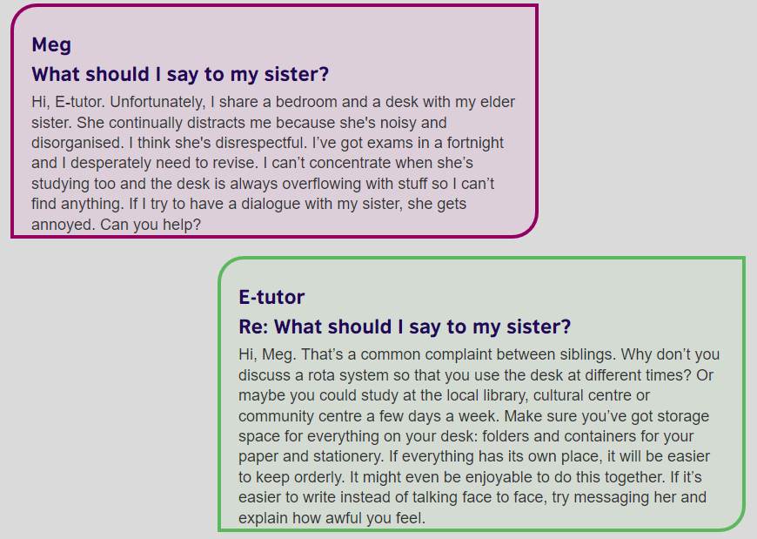

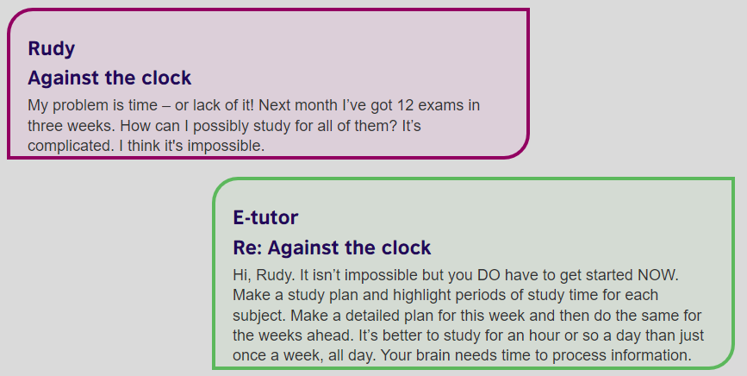

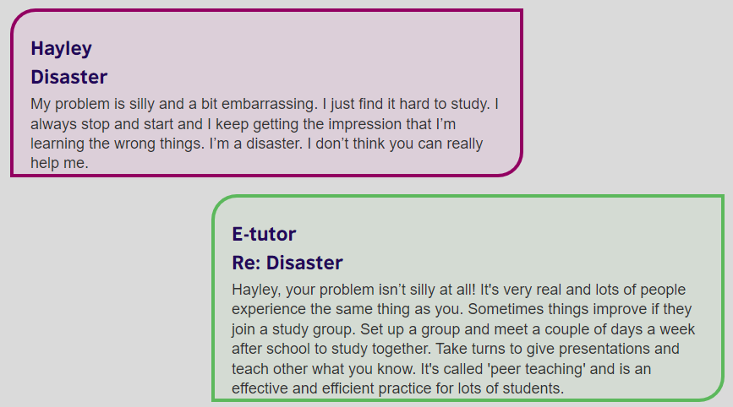

**Activity 13**: Who is it about? Put the sentences in the correct group.

1. This person shares study space with a member of the family.
2. This person is advised to create a detailed plan for studying.
3. This person isn’t sure about which things need to be studied.
4. This person feels embarrassed about a problem.
5. This person is advised to study outside the house.
6. This person is advised to study a little every day.
7. This person is advised to study with other people.
8. This person has exams in two weeks’ time.
9. This person is panicking because of insufficient time.

|  |  |  |
| --- | --- | --- |
| **Meg** | **Rudy** | **Hayley** |

**Activity 14:** Are the following sentences True (T) or False (F)?

1. _____________ Meg doesn’t respect her sister.
2. _____________ Meg finds it difficult to talk to her sister.
3. _____________ E-tutor thinks Meg’s problem is unusual.
4. _____________ Rudy believes he has an impossible task.
5. _____________ E-tutor thinks Rudy needs to start studying immediately.
6. _____________ Rudy needs to study a little and often.
7. _____________ Hayley is confident that her problem can be solved.
8. _____________ E-tutor recommends that Hayley studies with a teacher.

**Reading: Managing a problem.**

**Activity 15:** Match the phrase with the correct definition:

|  |  |  |
| --- | --- | --- |
| **Phrases** | **Definitions** | **Answers** |
| 1. To give someone a heads-up 2. To learn the ropes 3. To see the big picture 4. To feel stretched 5. To move the goalposts 6. To have a smooth-sailing experience 7. To feel pulled in both directions 8. To touch base with someone | 1. To tell or warn s.o that something is going to happen. 2. To have a more complete perspective on a situation. 3. To change the target or the rules of situations unfairly. 4. To feel as if people are making difficult demands of you that push you past what you are comfortable doing. 5. To learn the basics of how to perform a job or tasks. 6. To make brief contact with someone. 7. To be in a situation where you feel loyalty to two opposing groups. 8. To be able to progress without much difficulty. | 1:_____  2:_____  3: _____  4: _____  5: _____  6: _____  7: _____  8: _____ |

**Reading**

**From**: Jo Backhouse

**To**: Karl Anderson

**Date**: 17 October

**Subject**: Support for Judy

Dear Karl,

I received a call from Judy a couple of days ago to discuss some of the issues that she was having and I thought I'd give you a heads-up on what was said, seeing that you are Judy's project team leader.

Judy really enjoys working with you and the team and finds the project very interesting, but I think she's feeling a bit lost and struggling to see the big picture. It seems that she's been given a fair amount of autonomy to carry out the tasks that you've given her, and of course this level of delegation is not uncommon in your branch. But I believe in her Tokyo office, she is used to a bit more managerial direction and guidance and so is finding this international project quite daunting.

When I asked her about meeting her deadlines, she mentioned that due to the recent changes to the project timeline, her goalposts have been moved, and she doesn't seem to really understand why this has happened. Bearing in mind that she's also facing simultaneous deadlines from her department in Tokyo, we can presume that she might be feeling a bit stretched.

Looking ahead, I was wondering if we could make it easier for Judy by offering her more direction when setting her tasks, at least until she learns the ropes and gets used to working unsupervised. I think she'd also appreciate you giving her a clearer idea on how her role in the team fits into the overview of things. Do you think you could maybe outline the group and individual targets at your next team meeting and that way, everyone not only gets a reminder of the end goal, but each team member, including Judy, might have a more holistic view of the whole project?

I was also thinking it might help to touch base with her every so often to make sure that she's up to date with any changes to the overall plan of attack. In the meantime, I'll write to her manager in the Tokyo office and see how aware they are of the deadlines you've given her, and if they could in some way review her responsibilities and co-ordinate her tasks so that she doesn't constantly feel pulled in both directions.

Judy is an extremely conscientious worker and is eager to contribute positively to the team. Personally, I think she is someone with high potential and will be an asset to our international projects if properly mentored. I'm keen to know your thoughts on the matter and am open to any suggestions on how we could better support Judy so that she has a more smooth-sailing experience on the team.

Best regards,

Jo Backhouse

Head of Department

International Projects

**Activity 16:** Choose the best answer.

1. Why is Jo writing to Karl?
2. To suggest that his management style is not suitable for the current members of his team
3. To let him know about the issues his team member is facing and help him manage them
4. To tell him how to solve his problems.
5. To ask him to take it easy on Judy and not give her too much work

2. What is Judy not used to?

1. Being told what to do
2. Collaborating with people internationally
3. Being left to do things on her own
4. Delegating work to other people

3. Why is Judy confused by the changing targets?

1. She feels as if she needs to understand the reasons for the changes.
2. She has simultaneous deadlines from the Tokyo office.
3. She doesn't want to know the bigger picture, just her part.
4. She doesn't like meeting deadlines.

4. Who might benefit from having a better overview of the project and a better understanding of how the individual tasks fit together to achieve the group target?

1. Only Judy
2. Judy and the Tokyo office
3. Judy and Karl
4. Judy and the rest of Karl's team

5. What does Jo think of Judy?

1. Judy works well independently but isn't a good team player.
2. Judy is lazy and prefers managers to tell her exactly what to do.
3. Judy is very hard-working and capable and will go far in the company.
4. Judy is very enthusiastic but not very experienced.

6. Which of these does Jo do in her email?

1. Mix positives in with the negatives
2. Focus on the solutions
3. Use language to show that she's expressing her own opinion or a possibility and not hard facts
4. All of the above

**Activity 17:** Match the problems (A-D) with the solutions (1-4) that Jo suggests.

**Problems**

A. Judy is feeling stretched with multiple deadlines.

B. Judy can’t see the big picture.

C. Judy is not used to so much autonomy.

D. Judy finds the changing targets and deadlines confusing.

**Solutions**

1. Karl could outline the team and individual targets during the next week. _________

2. Karl could give her more direction until she learns the ropes. __________

3. Karl could touch base with her regularly and make sure she’s up to date with the changes. ________

4. Jo could write to Judy’s Tokyo office to make them aware of her deadlines and co-ordinate her tasks. _________

**Activity 18: Discussion**

How do you deal with problems at work? Have you ever had to write an email similar to this one? What would you do? Tell the class.